Foundation Subject Planning document

Mi casa
Login and password- westwoodnr33 westwoodnr33

 | Session 1 | Session 2 | Session 3 | Session 4 |  | Session 5 | Session 6
Learning Objective: | To ask and answer ‘where do you live?’ | To know the names of rooms in my house. | To say what is in your home. | To say what is not in your home |  | To interview a friend about where you live and what’s in your home | To write an extended paragraph.
Asessment | Emerging: I can say whether I live in a house or an apartment but find it hard to remember this at times. I may need to hear the model answer first.  I can say and write where my house or apartment is if I can hear the examples first and work from a model.  I can repeat and recognise all ten rooms of the house with their correct gender in Spanish  I can possibly even spell all of these words, but I will need to work with a word and/or picture bank in front of me.  I can ask somebody what rooms they have or do not have in their house and also answer this question back if I hear an example first. I find formulating the negative option more challenging.  I can attempt to integrate this new language into previously learnt language and say and write a longer passage incorporating some of my personal details, but I will find this more of a challenge. I will need assistance and a model answer first.  Expected : I can say and write whether I live in a house or an apartment with high accuracy.  I can say and write where my house or apartment is after I have heard the options available to me.  I can repeat and recognise most of the ten rooms of the house with their correct gender in Spanish. I can possibly spell over half of these words unaided from memory with good accuracy.  I can ask somebody what rooms they have or do not have in their home and also answer this question in return, including use of the negative if I have time to work out what I want to say and see an example first to remind me.  Exceeding:I can say and write whether I live in a house or an apartment.  I can say and write where my house or apartment is based using the choices given.  I can repeat and recognise all ten rooms of the house with their gender in Spanish. I can possibly even spell all of these words unaided with good accuracy.  I can ask somebody what rooms they have or do not have in their home and also answer this question back from memory including a negative reply.  I can integrate this new language into previously learnt language, saying and writing a longer passage about my home plus incorporating some of my personal details.
Task ideas including differentiation: | Recap como te llamas and cuantos tienes anos? Como estas?  Speaking and listening una casa and un piso.  Practice with partners- work through slides 2-10.  See grammar point below. Slides 11-16 practice having a conversation about where you live.  16-27 Where your house is (town ,mountain etc.)  Listening:activity in pairs?  Writing: Speech bubbles using word bank. HA without word bank LA fill the gaps | Recap- 1-8 slides.  Go through vocabulary 9-25  25-30 ABC quiz  31 - use the phrase En mi casa hay- practice with partners in the rooms.  Pg 39 matching the rooms up.  Move onto slide 45- children then practice orally some and then write some. Record some on vocaroo and put it into class book along with some of the examples of writing. | Recap last lessons 1-3.  Go through new rooms from 5-15.  Slide 25 recap all of the rooms learnt so far. Print out for children to do .Put some in class book after too.  En mi casa hay saying what is in their home. Slide 27- 36 Practising with their partner. Record some of these for class book on vocaroo.  Go through pg 43- 49. | Start at slide 6-14  Then practice using Mi casa no hay…up to slide 24.  Slide 44 Listening exercise.  Slide 47 to the end. Speaking practice with their partner. Record this for class books- could be filmed.  Children carry out survey. |  | Start at slide 9- 17 Children to practice interviewing their partner. Oral support to be used for those that need- two available. Record some for class book.  Slide 19 translation exercise to be done orally.  Carry out reading exercise and answer questions- put into class book. | Recap and revise the phonics from the unit- may need to change the powerpoint on the right handside.  Then show everybody the example email they are going to write- as a model.  LA- fill the gaps  MA- use the wordbak  HA- without the wordbank  Keep these for Spanish display.
Outcomes : | Class book: Writing speech bubbles.  Working wall: Add the vocabulary from today onto a washing line? | Working Wall  Add vocabulary on from today  Class book  Vocaroo recording, quiz answers  Names of the rooms | Working Wall  Add vocabulary on from today  Class book  Vocaroo recording.  Names of the rooms | Working Wall  Class book  Recording for class book mi casa hay and no hay  Survey findings |  | Working Wall  Class book  recording of interview, reading exercise | Working Wall  Class book  Emails for classbook and display.
Teacher phrases: Muy bien(very good)
Fantástico
Fenomenal
Excellente
Additional consolidation: | Research the different styles of homes there are in Spain. | Acting Game: Act out / mime that they are in a particular room of the home – EXAMPLE: Pretend to be asleep for un dormitorio (‘a bedroom’). | Create an ideal home labelled MI CASA detailing the various rooms they have inside. Use the key starter phrase “En mi casa hay ...

Lesson 1: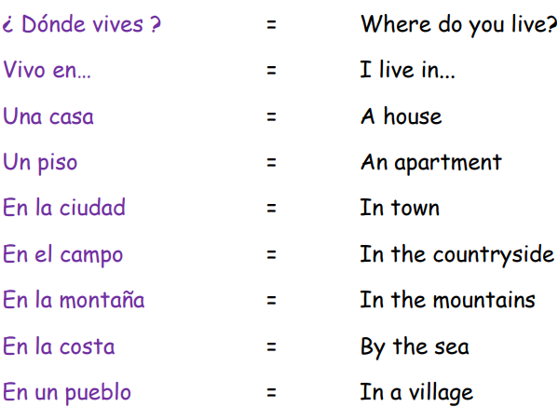Lesson 1:NB: Grammar Point In Spanish we normally drop the personal pronoun ‘I’ when using verbs. In this lesson pupils see the language structure ‘vivo en…’ as the Spanish for ‘I live in…” If we were to include the personal pronoun ‘yo’ (‘I’) then the full phrase would actually be ‘yo vivo en…’ However, in typical Spanish usage the ‘yo’ is dropped so the phrase for ‘I live in…’ is simply ‘vivo en…’ The ‘I’ personal pronoun is demonstrated and explained by how the verb ending is conjugated to ‘vivo’ which is the ‘I’ part of the verb ‘vivir’ (to live). The dropping of the personal pronoun ‘yo’ happens all the way through Spanish to keep the language fluent and flowing. It is something, therefore, that needs to be explained to your pupils.
Lesson2: 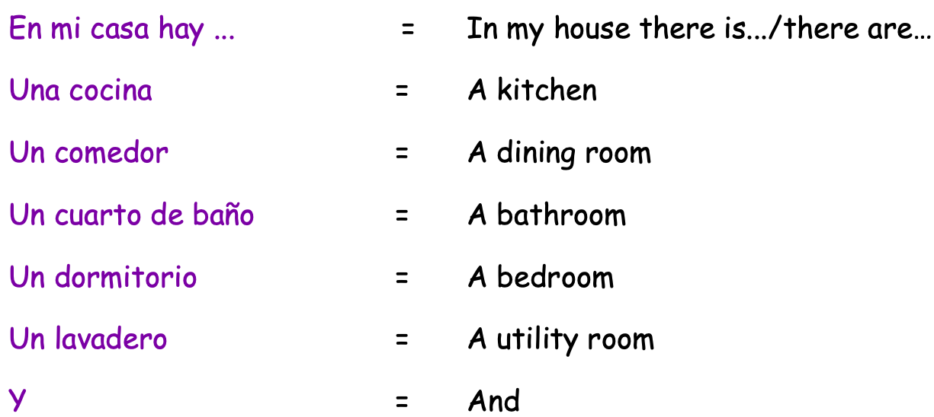Grammar Point We explain how, in Spanish, there are more ways to say ‘a’ than in English. We explain that all nouns in Spanish have “gender” and are either masculine or feminine. We explain that masculine nouns take the Spanish indefinite article (the word for “a”) “UN” and feminine nouns take the Spanish indefinite article “UNA”.
Lesson 3: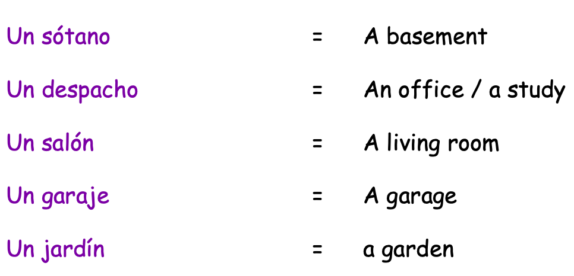
Lesson 4:
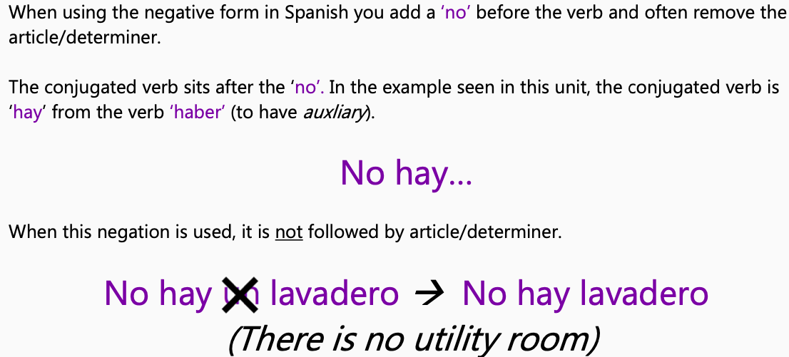

Lesson 5: 